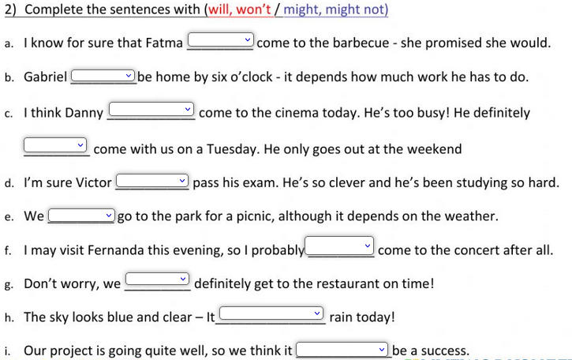

**1st CONDITIONAL**

1. If I ........................ (go) out tonight, I ..................... (go) to the cinema.
2. If you ..................... (get) back late, I ....................... (be) angry.
3. I ......................... (buy) a new dress if I ........................ (have) enough money.
4. If we ................. (not/see) each other tomorrow, we ................ (see) each other next week.
5. He ........................... (not/get) a better job if he ....................... (not/pass) that exam.
6. If he .................. (come), I .........................(be) surprised.
7. She ...................... (stay) in London if she ..................... (get) a job.
8. If we ........................ (wait) here, we .................... (be) late.
9. She ....................... (cook) dinner if you ................... (go) to the supermarket.
10. She ......................... (take) a taxi if it ....................... (rain).
11. If we .................... (go) on holiday this summer, we ........................ (go) to Spain.
12. If the weather ...................... (not/improve), we ....................... (not /have) a picnic.
13. I ................... (come) early if you ..................... (want).
14. If I.............. (not/go) to bed early, I ................... (be) tired tomorrow.
15. They ................................ (go) on holiday if they ........................ (have) time
16. If we .............. (eat) all this cake, we ...................... (feel) sick.
17. They ................... (go) to the party if they ....................... (be) invited.
18. If you ................. (not/want) to go out, I ...................... (cook) dinner at home.
19. We ................................. (be) late if we ........................... (not/hurry).
20. I ............................. (not/go) if you ........................... (not/come) with me.

**IF/UNLESS**

1. I will take the job **.......................** the pay is too low.

2. I will be back tomorrow **.......................** there is a plane strike.

3. Let’s go for a walk – **.......................** you are too tired.

4. I am going to work in the garden this afternoon, **.......................** it rains.

5. I will be surprised **.......................** he doesn’t have an accident soon.

6. I think she would look prettier **.......................** she didn’t wear so much make-up.

7. **.......................** you don’t stop smoking, you will fall seriously ill.

8. **.......................** you start now, you will not reach there in time.

9. **.......................** I were rich, I would spend all my time traveling.

10. **.......................** I have enough time tomorrow, I will come and see you.

**Rewrite the sentences by using "unless"**  
**Example**: I will go there if you don't call me. I will go there **unless you call** me.   
  
1. I won't forgive him if he doesn't apologize to me. I won't forgive him to me.  
2. They will go to picnic if it isn't cold tomorrow. They will go to picnic cold tomorrow.  
3. You can't travel to Germany if you don't have visa. You can't travel to Germany visa.  
4. I get very hungry at work if I don't have breakfast in the morning.  
I get very hungry at work breakfast in the morning.  
5. You can't graduate from school if you don't pass the final exams.

You can't graduate from school the final exams.

**Rewrite the sentences by using "if"**  
**Example:** I will go there unless you call me. I will go there **if you don't call** me.   
  
6. Don’t pay the money unless I call you. Don’t pay the money you.  
7. Unless you are tired let’s go for a walk at the park. tired let’s go for a walk.  
8. Unless she works hard, she won't get a promotion. hard, she won't get a promotion.  
9. Don't sign the document unless you read it carefully. Don't sign the document it carefully.  
10. He mustn't drive unless he has a driver's license. He mustn't drive a driver's license.

KEY:

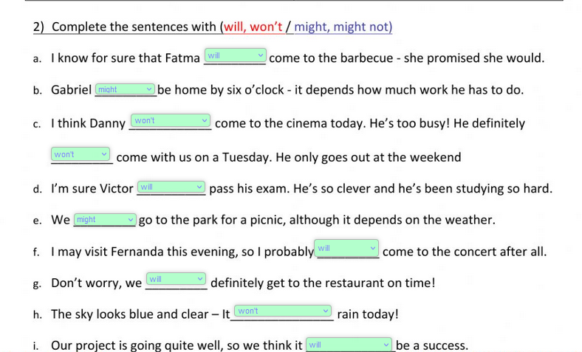

**Answers**

1. I will take the job **unless** the pay is too low.

2. I will be back tomorrow **unless** there is a plane strike.

3. Let’s go for a walk – **unless** you are too tired.

4. I am going to work in the garden this afternoon, **unless** it rains.

5. I will be surprised **if** he doesn’t have an accident soon.

6. I think she would look prettier **if** she didn’t wear so much make-up.

7. **If** you don’t stop smoking, you will fall seriously ill.

8. **Unless** you start now, you will not reach there in time.

9. **If** I were rich, I would spend all my time traveling.

10. **If** I have enough time tomorrow, I will come and see you.